Audio | Visuals
An enormous iceberg has calved from Antarctica’s Brunt Ice Shelf. | Sentinel-1 animation
After several years of desperately clinging on, the berg broke away as confirmed by satellite data. | Show this animation
Scientists estimate the new berg to be around 1550 sq km. That’s the size of Greater London or five times the size of Malta. | Show the right side of this image:  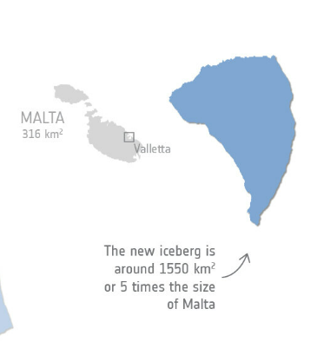
The Brunt Ice Shelf borders the Coats Land coast in the Weddell Sea sector of Antarctica. | Show Brunt Ice Shelf map  Zoom into gold circle here
Glaciologists have monitored the thick Brunt Ice Shelf for years. | Show this footage
The new berg calved when the crack known as Chasm-1 split northwards severing the west part of the ice shelf. | Show converging cracks animation
It was only a matter of time before it would meet the Halloween Crack – first spotted on, you guessed it, Halloween. | Show 00:19 in the animation above and pause.
Voice of Mark Drinkwater:  After several years on watch for Brunt iceberg calving, we finally witnessed the long-awaited separation of the western Brunt ice shelf as iceberg A-81. | Video footage of Brunt ice shelf here  Text on screen:  Voice of ESA’s Mark Drinkwater
Routine monitoring from satellites offers unparalleled views of events happening in remote regions. | (Continue footage)
The Copernicus Sentinel-1 mission carries radar, which returns images regardless of day or night. | Show fly by of Sentinel-1 mission
This allows us year-round viewing, which is especially important through the long, dark, winter months. | Shot of Sentinel-1 radar capabilities
The British Antarctic Survey’s Halley VI Research Station, where glaciologists have been monitoring the behaviour of the ice shelf, was relocated in 2017 to a more secure location after the ice shelf was deemed unsafe. | Show shot of Halley research station. Images here: Gallery
The station has remained unaffected by the calving event. | Gallery
There are currently 21 staff working at the station to keep scientific operations running through winter.  It is now around 20 km from the line of rupture. | Ppics of the station
Mark Drinkwater:  Thanks to the Copernicus Sentinel satellites, together with in situ and airborne measurements made by the British Antarctic Survey, the safety of the Halley Base has been preserved. | Show footage/pic of station  Text on screen:  Voice of ESA’s Mark Drinkwater
In February 2021, a giant berg broke off from the northern section of Brunt. | Show this animation
Spotted by Sentinel-1, it has already drifted away from the Brunt Ice Shelf into the Weddell Sea. | (Continued)
So, what happens now? | Zoom in close to Sentinel-2 image here
The calving of ice bergs can speed up the flow of ice from an ice shelf. If Brunt now experiences an acceleration, it could influence the behaviour of other cracks in the area. | (Continued)
Mark Drinkwater:  The calving and separation of the latest iceberg A81 now focuses attention back onto the Halloween crack – whose extension could contribute to further destabilisation of the remaining eastern portion of the Brunt Ice Shelf. | Text on screen:  Voice of ESA’s Mark Drinkwater
Mark:  We will continue using the Copernicus Sentinel satellites to closely monitor the behaviour and stability of the remaining Brunt Ice Shelf. | Text on screen:  Voice of ESA’s Mark Drinkwater

